**Problem Solving Process**

**Class 9**

**Lab 5**

|  |
| --- |
| Lab Objectives:  * Solving some serious common problems |

# Mathematical, Relational and Logical Operator and their symbols

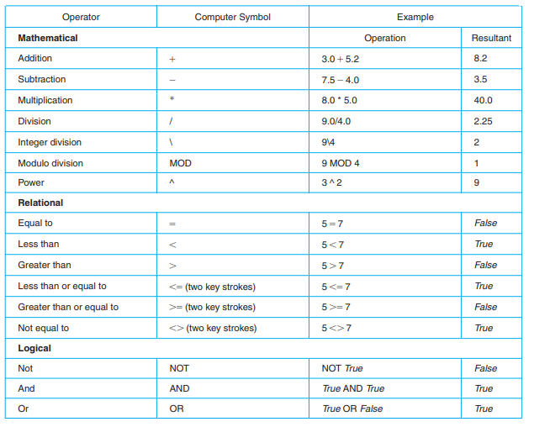

# Definitions of the Logical Operators

# Hierarchy of Operations

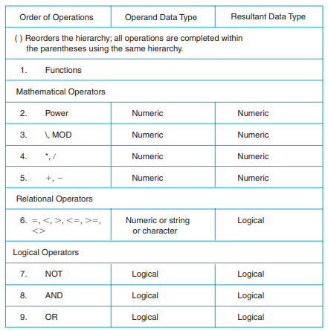

## The following exercise illustrate how to use the concepts you’ve learned in class eight to write and evaluate expressions and equations. Try to answer all of this questions

# Exercise 1: Name the data type for each of the following constants. Explain your answer.

## a.5.38

## b. “87654”

## c.True

## d. “A”

## e. “707-434-5555”

## f. “New York”

## g. -389

## h. 2.45E6

## i. 48976.0

## j. False

# Exercise 2: Find the result of the following operations:

## a. 5 + 4

## b. 10/2

## c. True OR False

## d. 20 MOD 3

## e. 5 6 8

## f. 25 MOD 70

## g. “A” 7 “H”

## h. NOT True

## i. 25\70

## j. False AND True

## k. 20 \* 0.5

## l. 35 6= 35

## m. 35/7

## n. False OR False

## o. True AND True

## p. 50 MOD 5

## q. -35 6 67

## r. 4.0 ^ 3

## s. 60\9

## t. 35 6 35

## u. True AND False

# Exercise 3: Evaluate the following equations, given the values A = 12, B = 3, C = 6, D = 2:

# Selection_015